**name-sorter**

Author: Evi Juwita

Date: 20 October 2018

This project is generated as an employee skill assesment for PT. Kreatifitas Sinergisme Teknoindo.

Table of Contents

1. **Introduction**

The program [name-sorter] is a console application that will sort a list of names. User can submit a file path in text form, and [name-sorter] will extract the names listed on the file. Next, [name-sorter] sorts names based on surname, then by given name respectively. User can then view the result on screen and on an output file, called [sorted-names-list.txt] on the same directory as the input file.

There are two main points discussed in this document; installation manual and technical design manual. Installation manual elaborates on how to install [name-sorter] on PC / laptop (running on Windows for now), technical design manual describes more on [name-sorter] design that acts as technical design guidance and reference for future development.

1. **Installation Manual**

The generated [*.exe*] file should be available before starting the [name-sorter] installation. Besides, there is a folder named [*name-sorter.installer*] along with this document for this [name-sorter] installation purposes.

Installing [name-sorter] requires a user to simply copy and paste the entire files under [*name-sorter.installer*] directory. The same method also applies when installation files exist in a different folder. In the case when the installation files exist in a compressed form (or zipped form), then user may extract the installer to a desired location.

To check if the installation went properly, simply run [name-sorter] by following three steps below:

1. Open command prompt

[Windows key + r] ⮞ [Type: cmd]

or

[Go to Start menu] ⮞ [Windows System] ⮞ [Command Prompt]

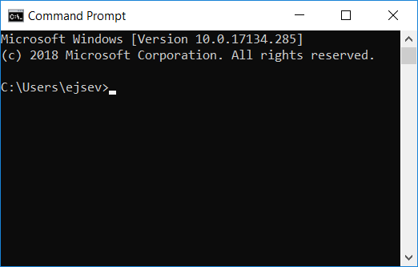  
Drawing 1: Command Prompt Window

1. Run [name-sorter]

On command prompt, navigate to [name-sorter] folder ⮞ [Type: name-sorter ./unsorted-names-list.txt]

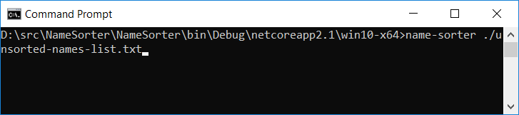  
Drawing 2: Navigate to [name-sorter] Installation Location

1. View result

There should be names listed in orderly manner printed on screen. For certainty, there should also be a file called [sorted-names-list.txt] under the same folder as [unsorted-names-list.txt] file.

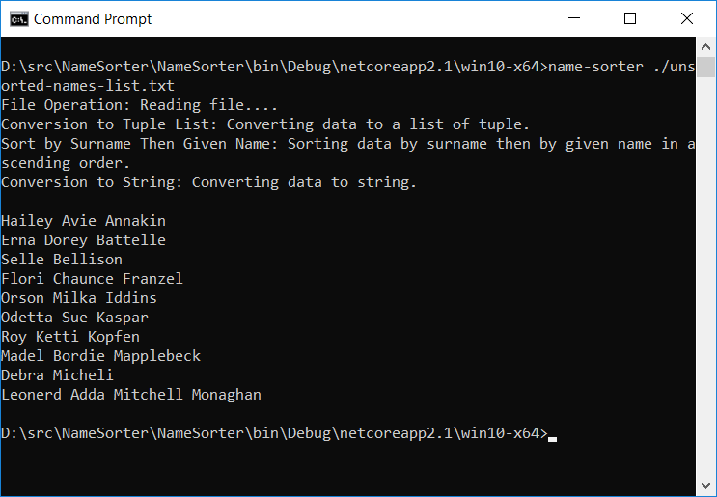  
Drawing 3: Running [name-sorter]

1. **Technical Design Manual**

Program [name-sorter] follows design pattern concept. Following OOP concept, [name-sorter] follows an analogy where a regular customer goes to a bank to open a new account. The customer enters the bank, and meets the [*Customer Service*] officer that tackles all client requests. Knowing the type of request, [*Customer Service*] officer will give the appropriate form. The customer fills out the form and submits it to [*Customer Service*] officer for further processing.

There should be a smart person in the background that assists [*Customer Service*] officer that handles requests, including but not limited to approving or rejecting the process of generating an account for the customer. When a bank account number is created, bank should prepare a record book that customer can keep to track his banking transaction. Depending on whether or not the customer requires an ATM card, the [*Customer Service*] should ask the appropriate [*Back Office*] to generate an ATM card for the customer.

The same story applies for [name-sorter]. As soon as the [*Main Program*] receives a request to sort names on a certain file, it will call for the [*Customer Service*] officer to tackle the request. [*Customer Service*] officer shall choose among all available services, which one is the suitable service for this particular sort request.

Then, sort request goes to the [*Back Office*] that sorts data technically, and return the result back to the [*Customer Service*] officer. [*Customer Service*] will go to the *writer* staff, to prepare a notification letter for the customer. The letter contains the result of the sort process.

Roughly, the class diagram of [name-sorter] is as follows:

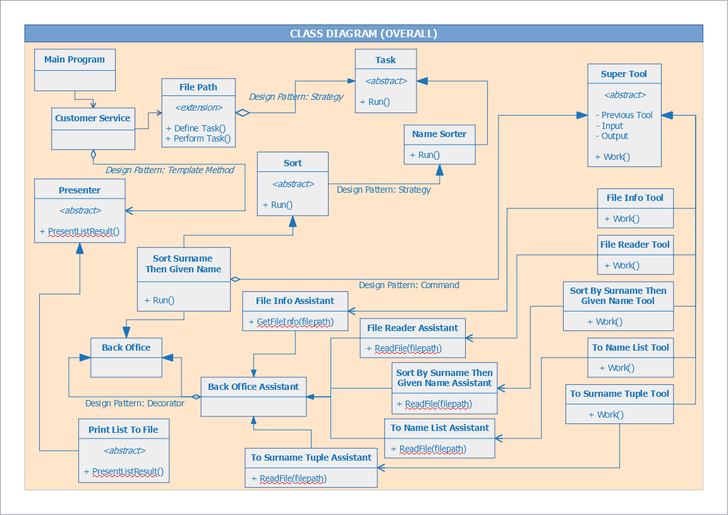  
Drawing 4: Class Diagram (Overall)

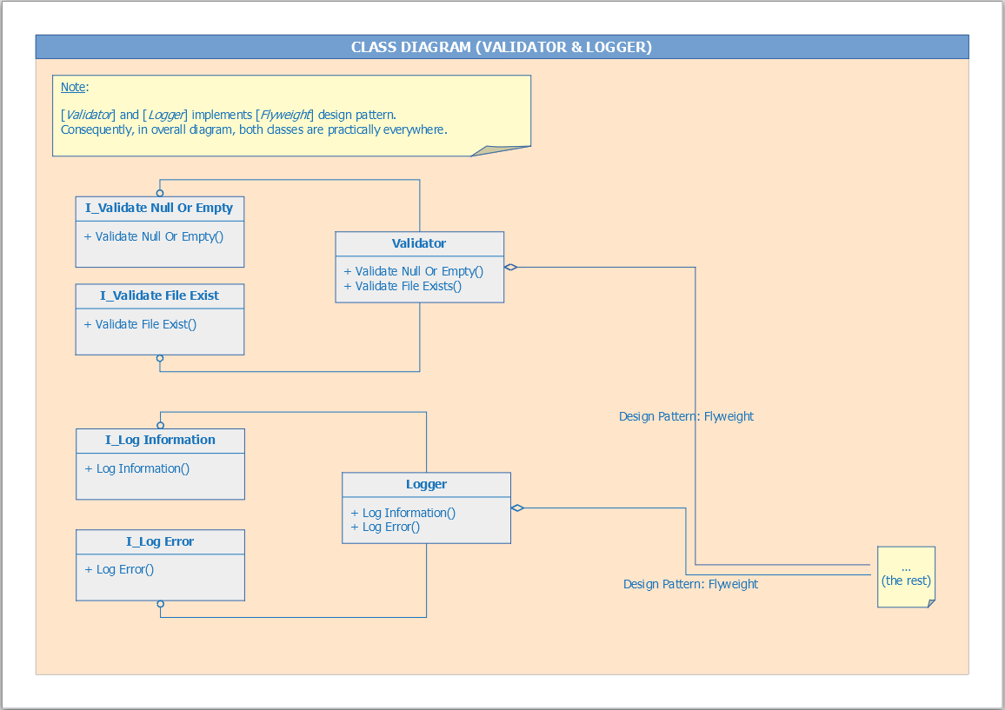  
Drawing 5: Class Diagram (Validator & Logger)

As proof of concept, the following sequence diagram illustrates data flow within [name-sorter]: